The VA’s high hopes for psychedelics
By ERIN SCHUMAKER, SHAWN ZELLER, DANIEL PAYNE and RUTH READER

05/10/2024 02:00 PM EDT

AROUND THE AGENCIES
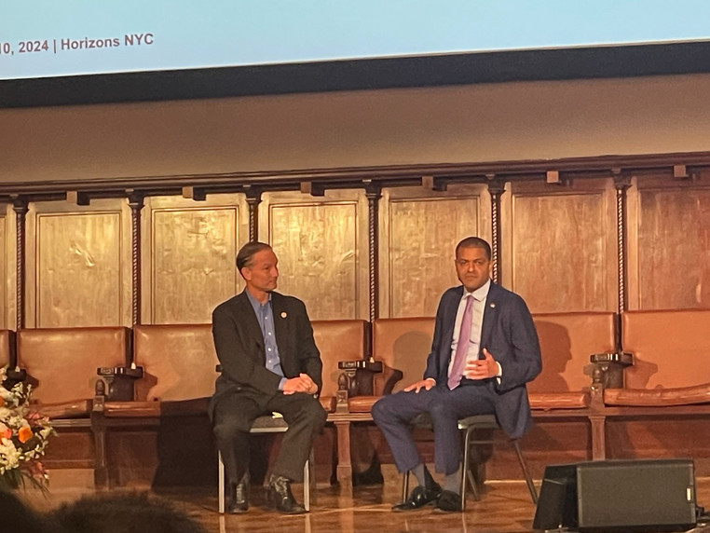
The VA's Elnahal (right) got a warm reception at a psychedelics conference in New York today. | Erin Schumaker/POLITICO
“The more you continue to prove the case on this and the more you help us set up the case for veterans, the easier the VA will be able to take this and run with it.”
DR. SHEREEF ELNAHAL, THE UNDERSECRETARY FOR HEALTH AT THE DEPARTMENT OF VETERANS AFFAIRS
Dr. Shereef Elnahal, the undersecretary for health at the Department of Veterans Affairs, found kindred spirits at a conference in New York today put on by the Horizons Center Public Benefit Corp., which promotes psychedelic drugs.
How so? The VA announced in January that it would fund research into psychedelics like MDMA, also known as ecstasy, and psilocybin as potential treatments for post-traumatic stress disorder and depression. While outside groups have funded studies at the VA, it’s the first time since the 1960s that the agency has put money toward psychedelic research.
The agency has about 13 psychedelic studies underway and is looking to expand, Elnahal said Friday.
For that work, Elnahal received a standing ovation.
“We keep proving the science. We keep surprising the folks who are skeptical,” he told the crowd.
Why the VA matters: It’s the largest health system in the country and serves a population with disproportionately high rates of PTSD.
About 5 percent of Americans have PTSD in any given year, according to the Department of Veterans Affairs. Veterans, especially those who have deployed, are more likely than civilians to have PTSD. Both male and female veterans with PTSD are at a higher risk for suicide than veterans without the condition.
Current treatments for PTSD, like antidepressants, carry side effects and don’t work for everyone.
Jeff George, chairman of the board at drugmaker Lykos Therapeutics, whose new drug application for MDMA combined with therapy the Food and Drug Administration is considering, highlighted the importance of agency support in bringing psychedelic medicine to the mainstream during the Horizons conference.
In addition to the FDA, “the VA plays a huge role,” he said. It’s not just veterans, he added, noting that a large proportion of doctors train in the VA system.
In a divided Congress, psychedelic research is also a rare bipartisan issue, George and Elnahal pointed out. “There aren’t a lot of purple issues that bring together Trumpers and the left-wing like psychedelics,” George said.
Bipartisan congressional support should motivate the scientific community to conduct rigorous and ethical work, Elnahal said: “As long as we do that, bipartisan support will only get stronger.”
What’s next? The FDA is holding an advisory committee meeting on June 4 to consider Lykos’ application. If the FDA approves, the Drug Enforcement Administration would still have to reschedule MDMA before doctors could prescribe it to patients.
“The moment FDA approves MDMA — and I don’t have any insight into that,” Elnahal said, “We’re going to see demand for this go through the roof, especially among the veteran population

